**Project Report JOB APPLICATION TRACKING SYSTEM**

**1 INTRODUCTION**

* 1. Overview

Create a CRM application which helps the applicant to track the number of jobs he/she applied. It helps him/her to find the job posted by the various recruiters.Find the best attributes to be involved to run the process in a smooth way and easily to track.

1.2 Purpose

It helps the candidate to track the number of jobs he/she applied and helps the candidate to track the status of applications.

1. **PROBLEM DEFINITION AND DESIGN THINKING**

2.1 Empathy Map

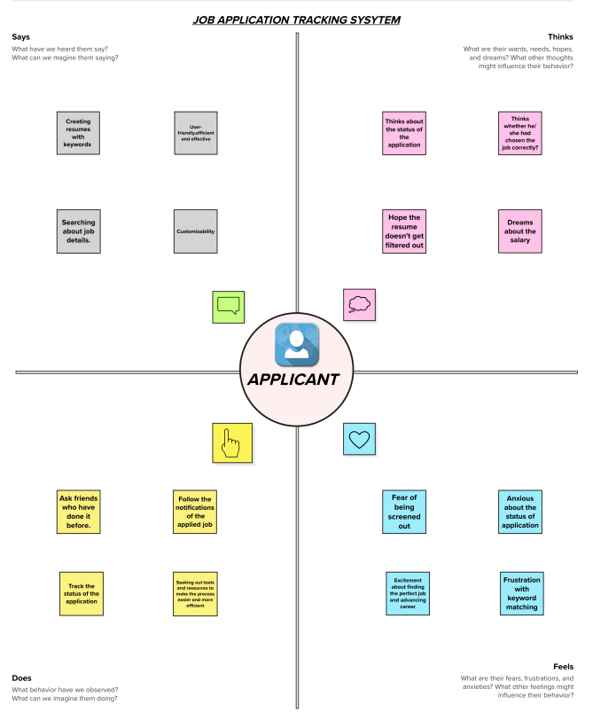

2.2 Ideation & Brainstorming Map

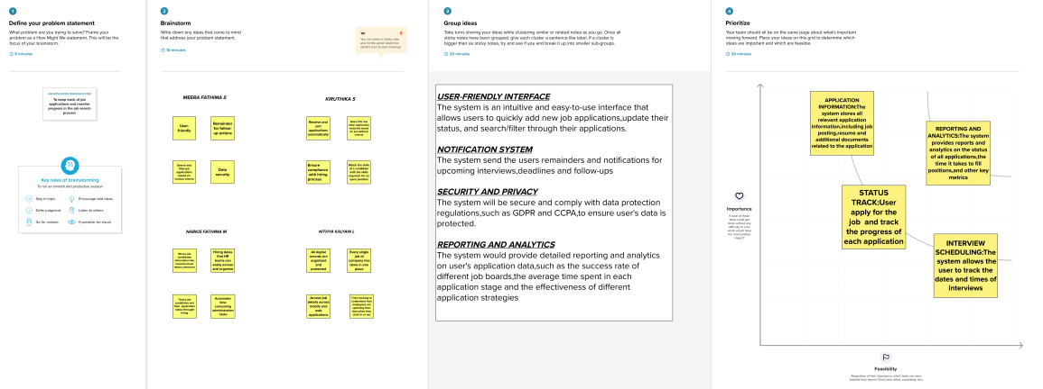

**3 RESULT**

3.1 Data Model:

|  |  |
| --- | --- |
| **OBJECT NAME** | **FIELDS IN THE OBJECT** |
| JOB | |  |  | | --- | --- | | FIELD LABEL | DATA TYPE | | Job Number | Auto Number | | Job Name | Text(30) | | Description | Text Area(255) | | Location | Text(30) | | Qualification | Text(25) | | Recruiter | Master-Detail(Recruiter) | |
| JOB APPLICATION | |  |  | | --- | --- | | FIELD LABEL | DATA TYPE | | Application Id | Text(30) | | Job Application Number | Auto Number | | Job Title | Text(25) | | Applied Date | Date | | Candidate | Master-Detail(Candidate) | |
| CANDIDATE | |  |  | | --- | --- | | FIELD LABEL | DATA TYPE | | Candidate Name | Text(30) | | Candidate Number | Auto Number | | Qualification | Text(53) | | Email Id | Email(Unique) | | Phone | Phone | | Location | Text(243) | |
| RECRUITER | |  |  | | --- | --- | | FIELD LABEL | DATA TYPE | | Job Title | Text(30) | | Recruiter Number | Auto Number | |

**3.2 Activity & Screenshot**

**\*CREATION OF CUSTOM OBJECT:**

**1.Recruiter**

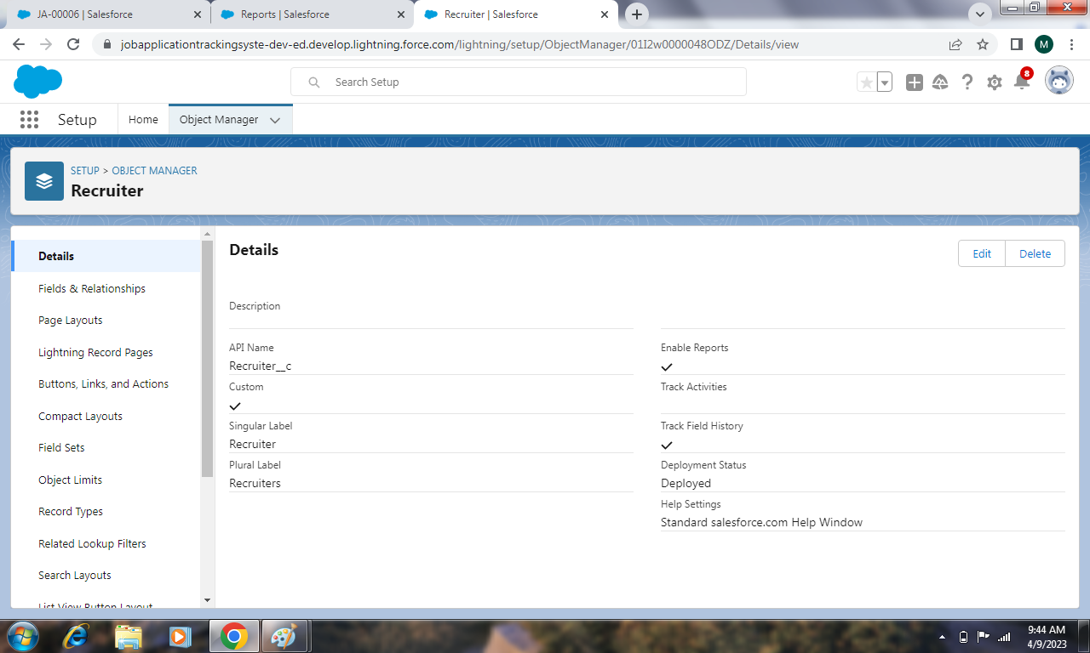

Creating custom object with label name” Recruiter”, record name “Recruiter Number” and data type as “Auto Number”

**2.Job**

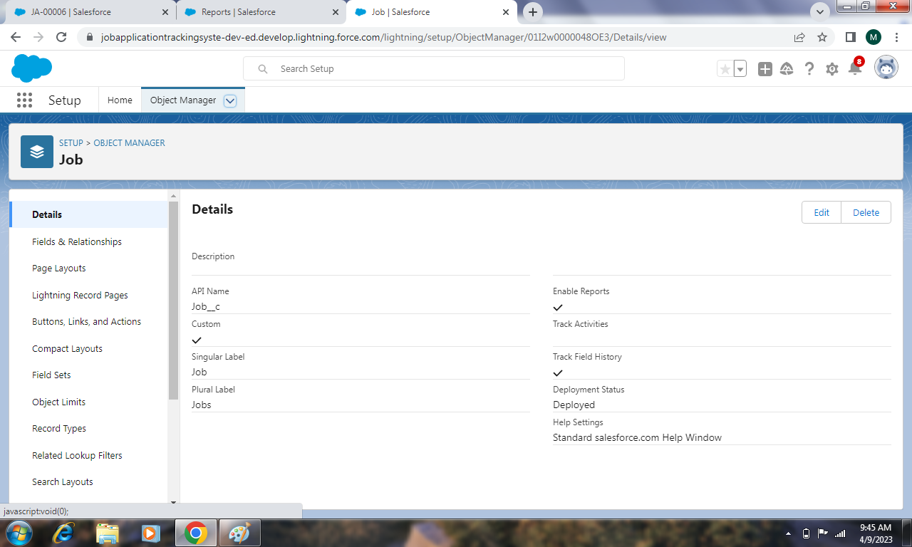

Creating custom object with label name” Job”, record name “Job Number” and data type as “Auto Number”

**3.Job Application**

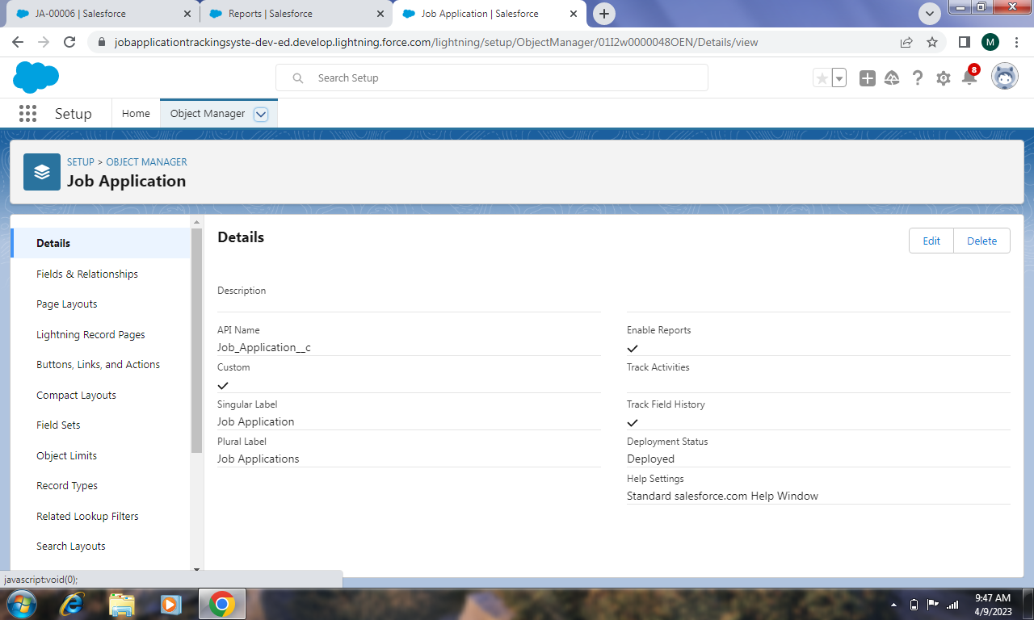

Creating custom object with label name”Job Application”, record name “Job Number” and data type as “Auto Number”

**4.Candidate**

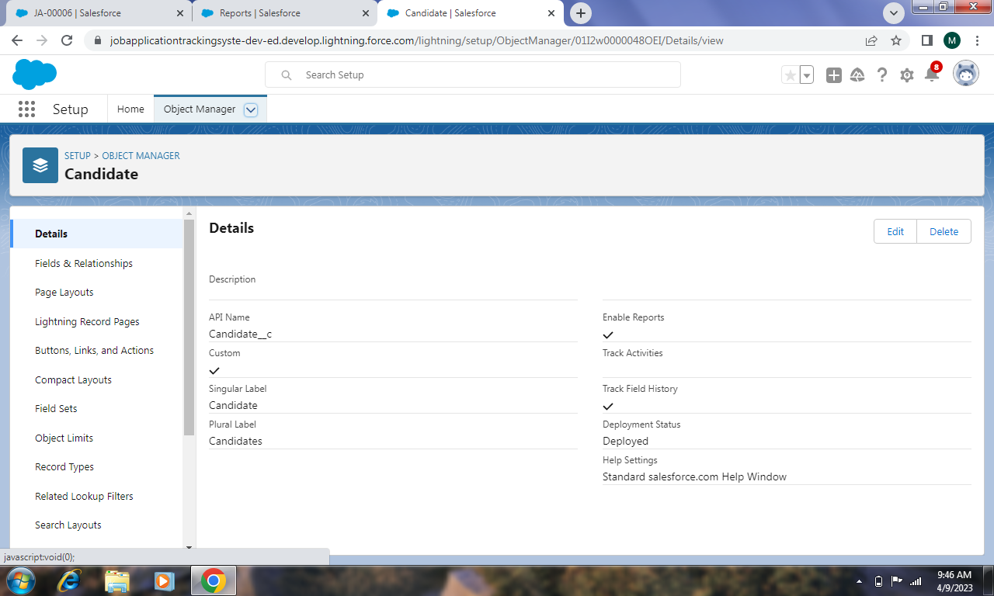

Creating custom object with label name” Candidate”, record name “Candidate Number” and data type as “Auto Number”

**\*CREATION OF FIELD AND RELATIONSHIP:**

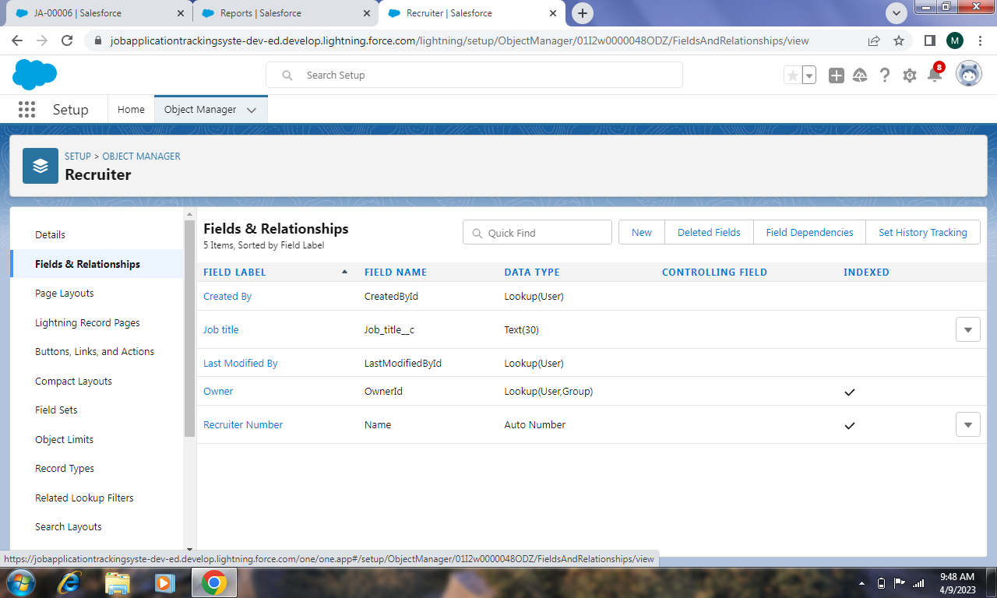

**2.Job**

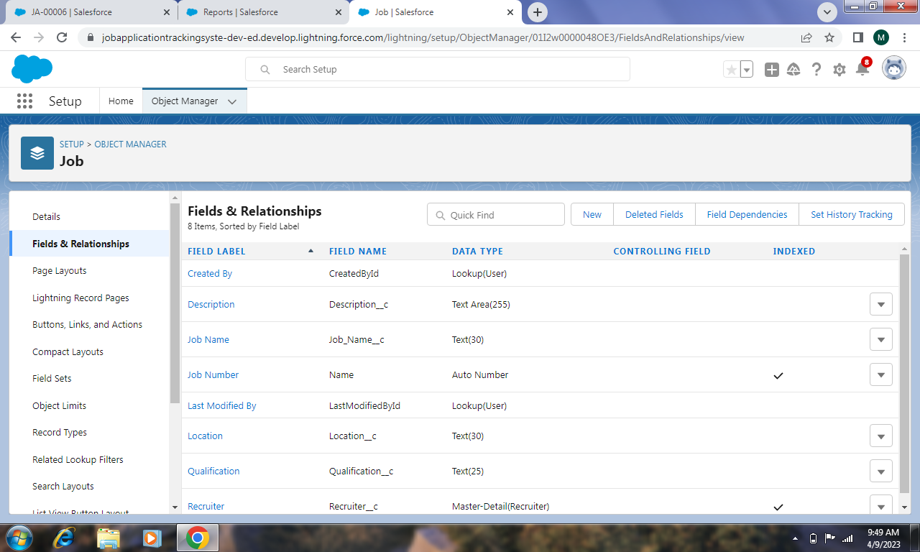

**3.Job Application**

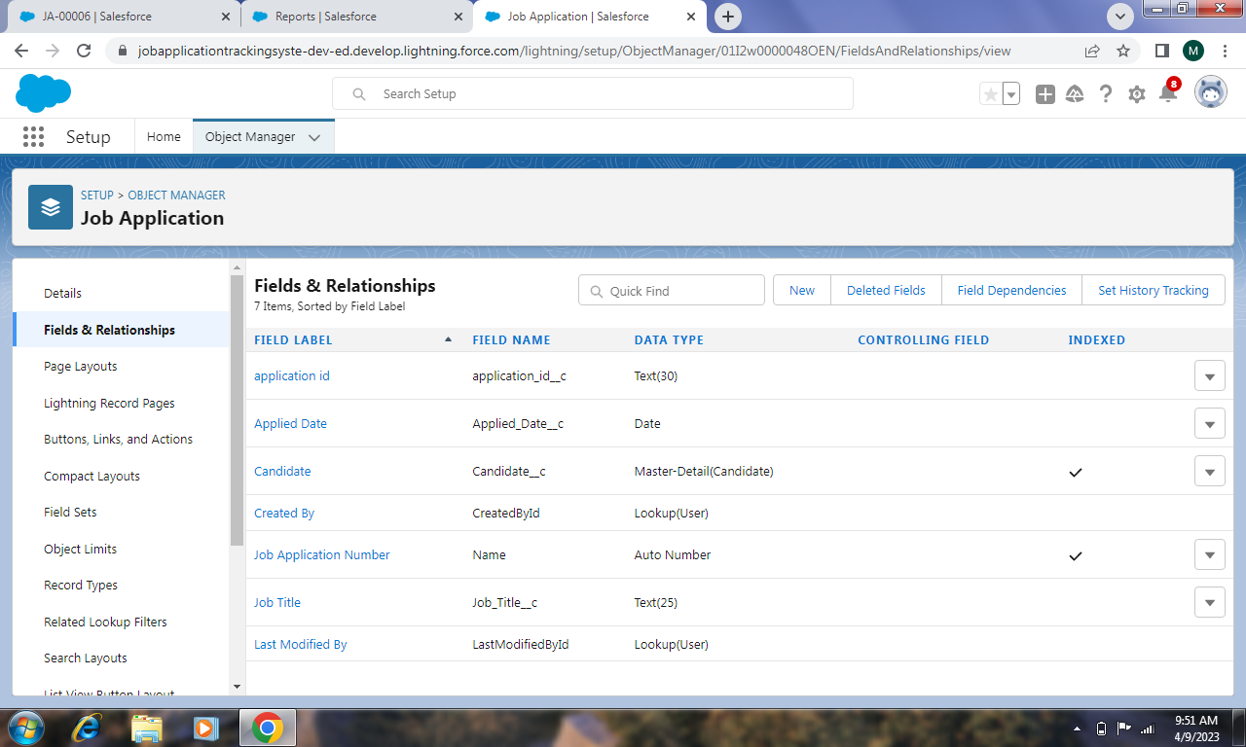

**4.Candidate**

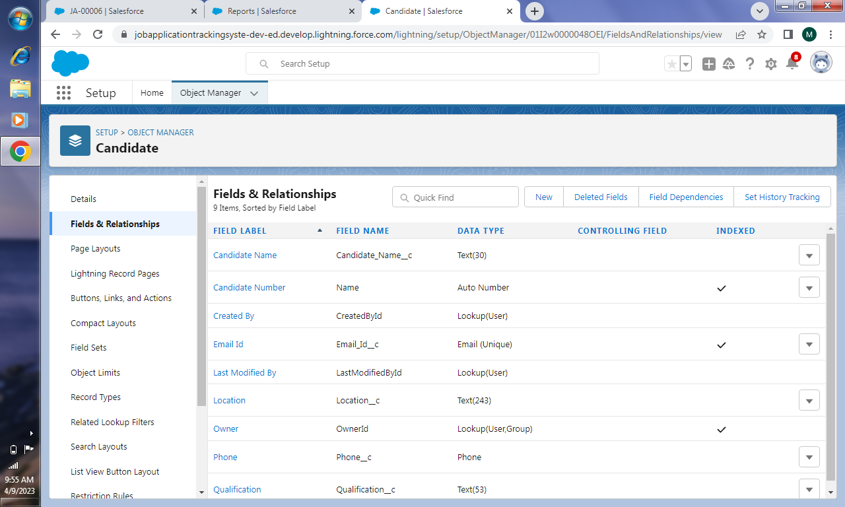

**\*CREATION OF TAB:**

Creating tab for those custom objects

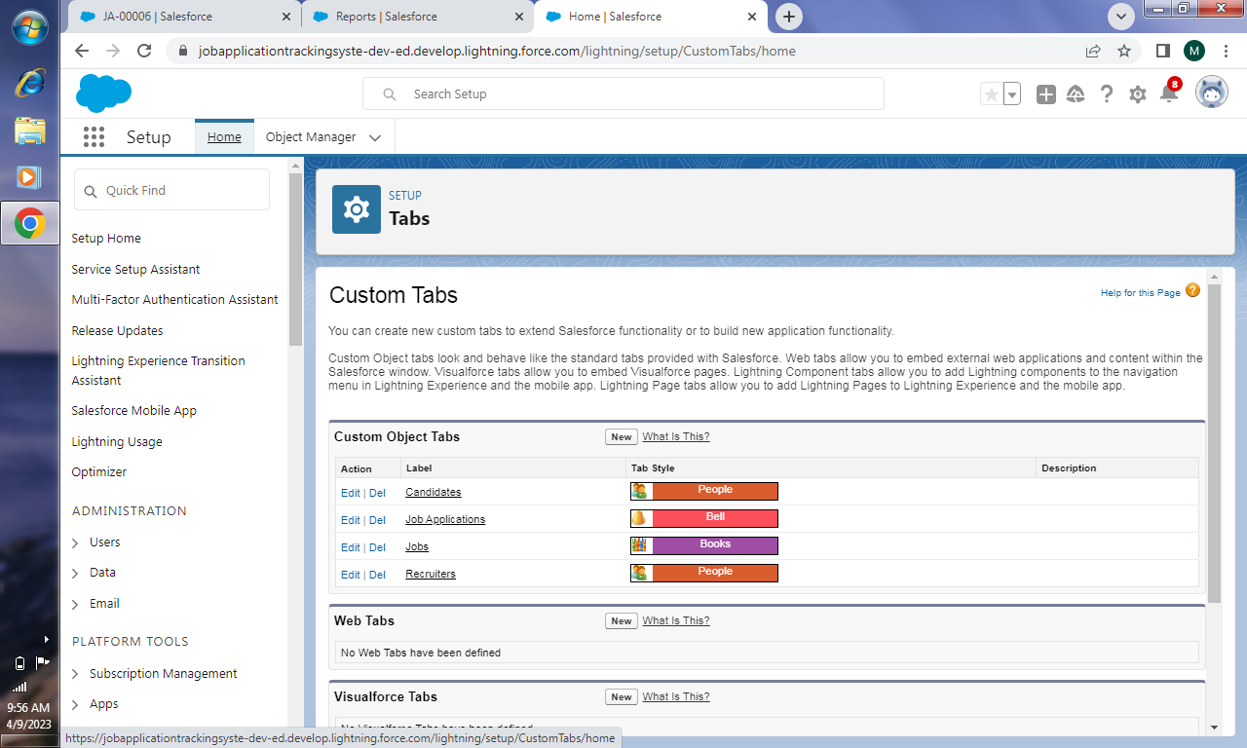

**\*CREATION OF PROFILE:**

1.Creation of profile with profile name as ”Recruiter”

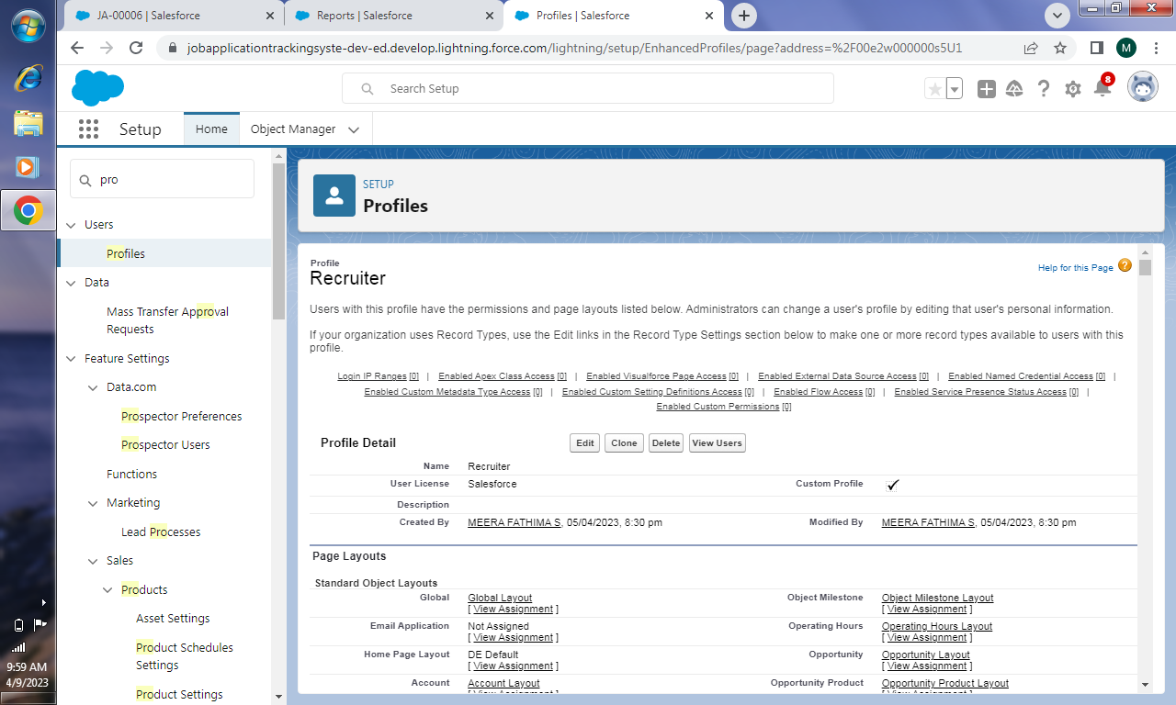

2.Creation of profile with profile name as ”Sales Manager”

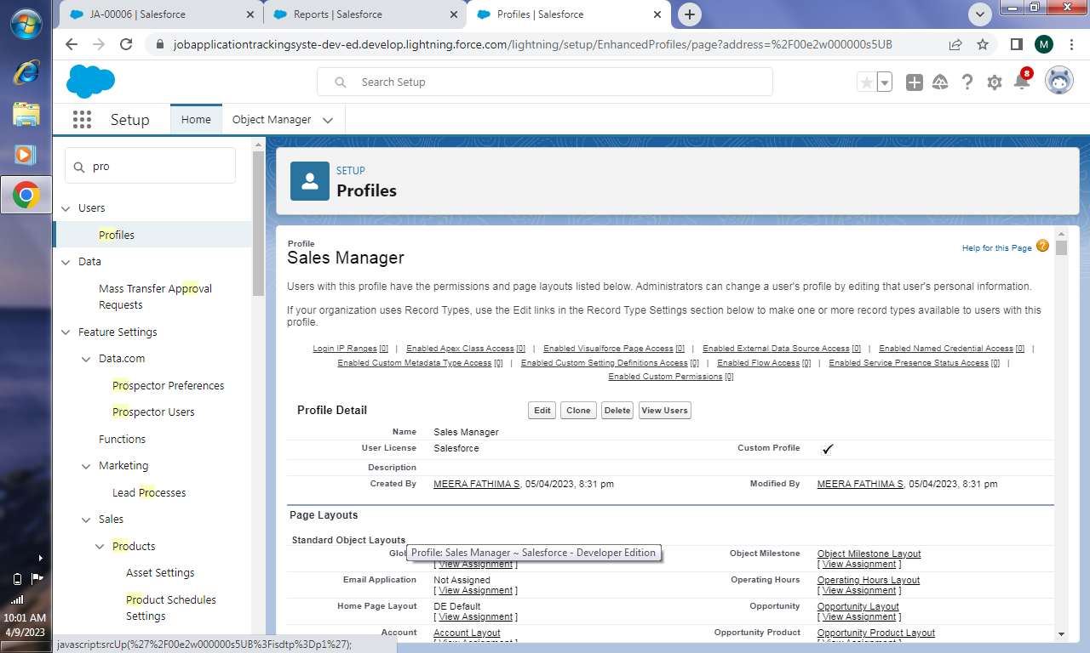

**\*CREATION OF USER:**

1.

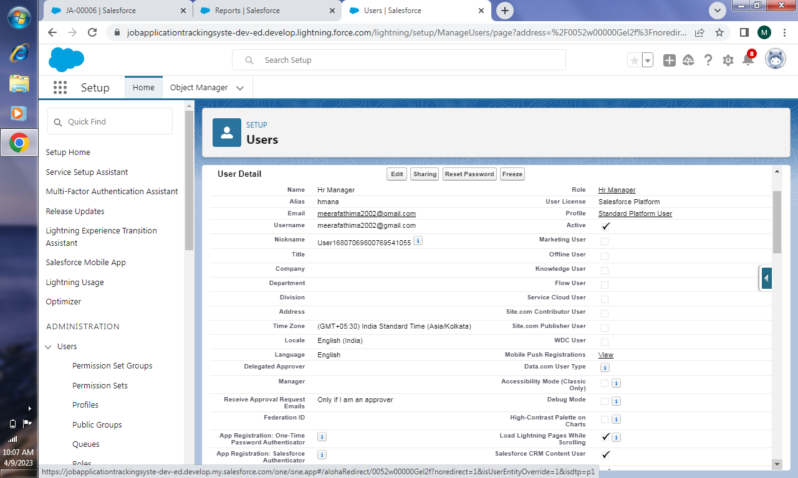

2.

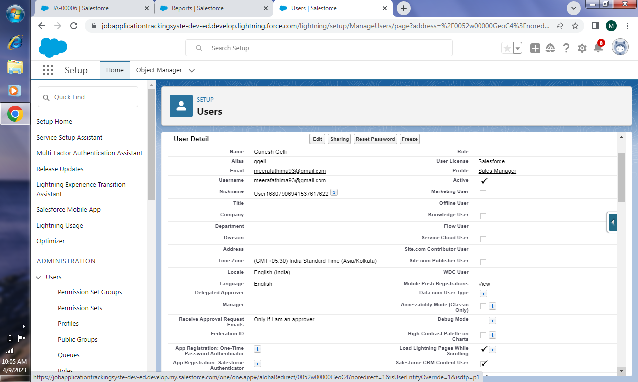

**\*CREATION OF SHARING RULE:**

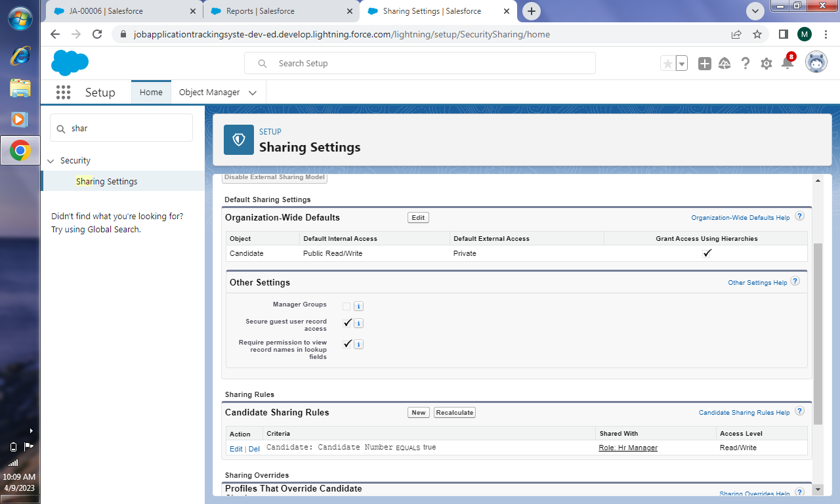

**\*CREATION OF REPORT:**

Creating report for the custom objects with the help of the fields

1.Report for account

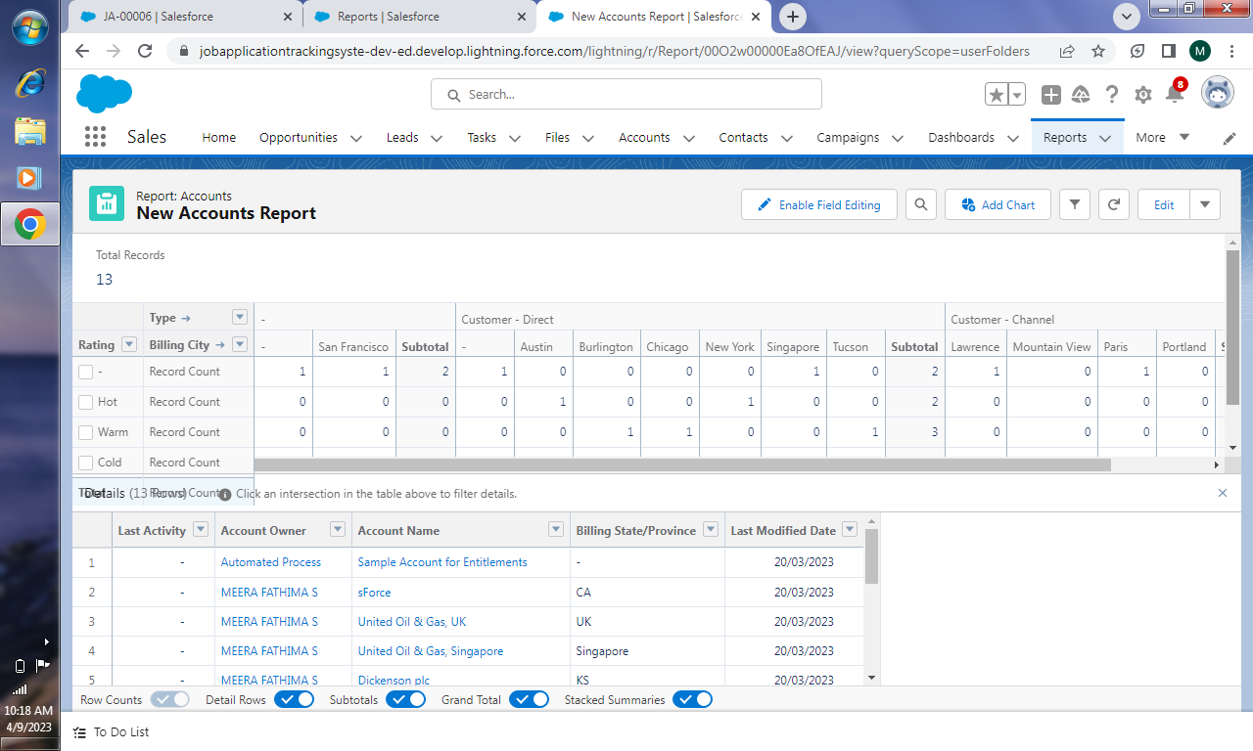

2.Report for job

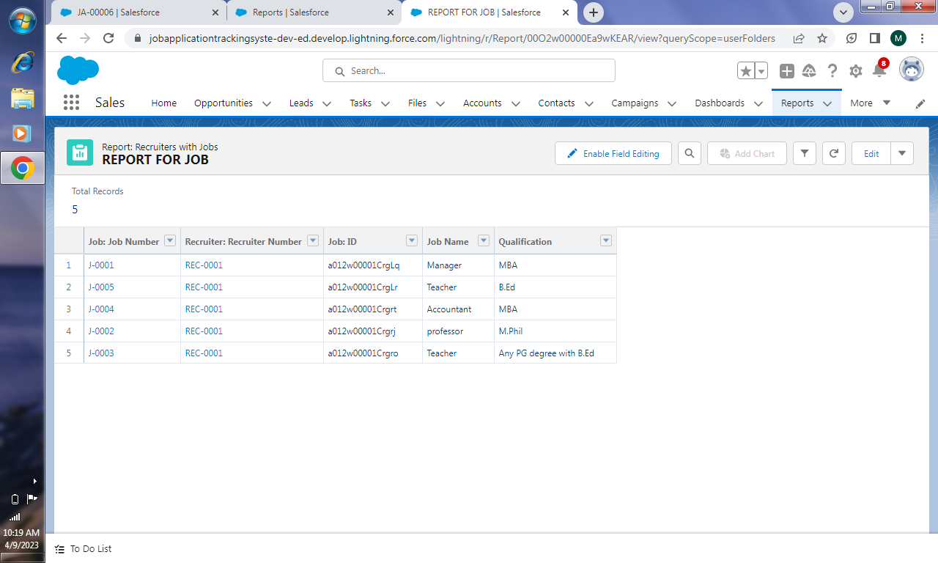

3.Report for job application

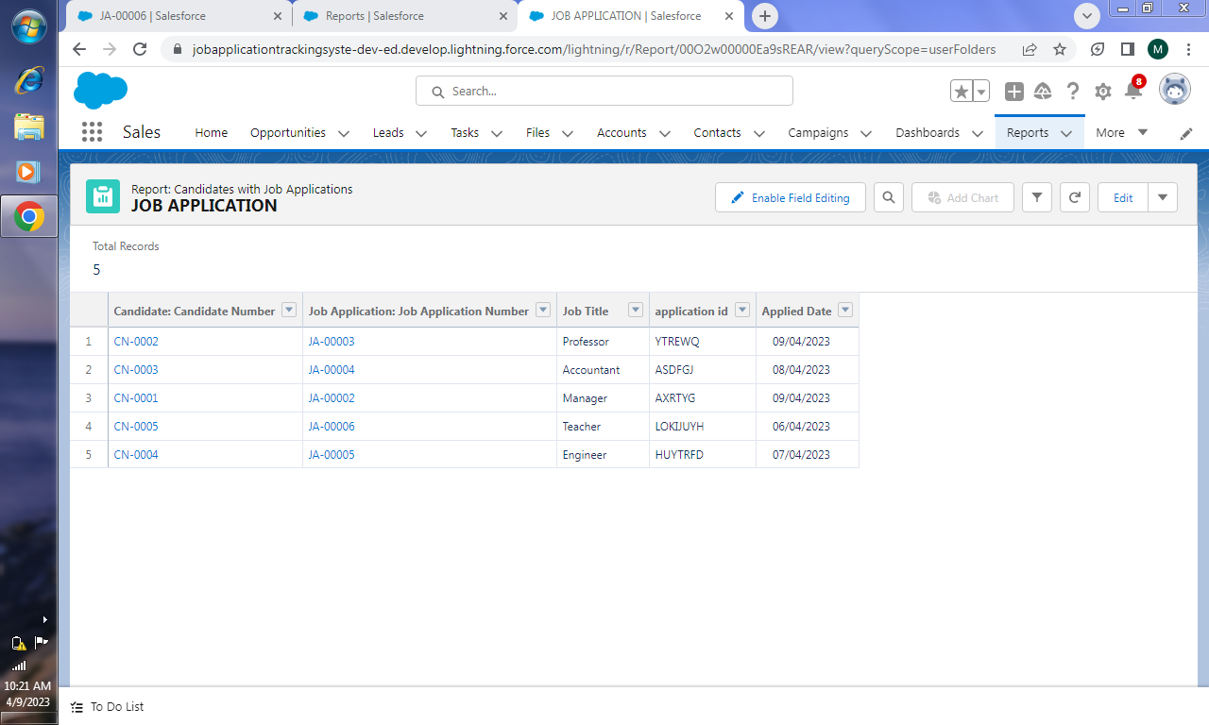

4.Report for candidate

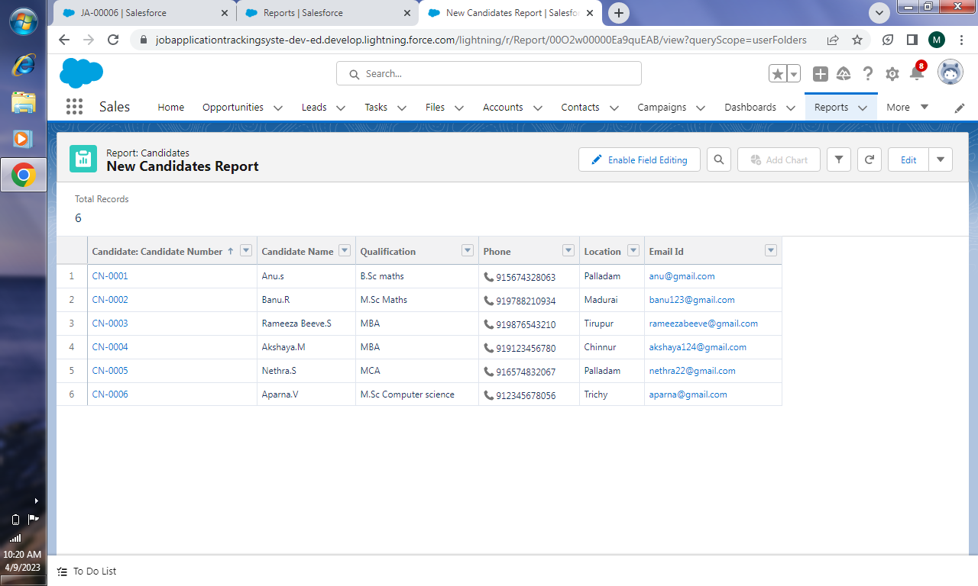

**4 TRAILHEAD PROFILE PUBLIC URL**

Team lead (MEERA FATHIMA.S) : <https://trailblazer.me/id/mfathimas>

Team Member1 (KIRUTHIKA.S) : <https://trailblazer.me/id/skiruthika3>

Team Member2 (NARKISFATHIMA.M) : <https://trailblazer.me/id/nfathima29>

Team Member3 (NITHYA KALYANI.L) :<https://trailblazer.me/id/nithyakalyani77>

**5 ADVANTAGES & DISADVANTAGES**

ADVANTAGES:

* Saves time,manual efforts and cost.
* The candidate’s data and activity history is within easy reach.
* Enhances reporting and compliance.
* Reliable,convenient and easy-to-use software.
* Facilitate collaboration.

DISADVANTAGES:

* Only focusses on data/analytical information.
* Not immune to technical difficulties.
* Harder to integrate.

**6 APPLICATIONS**

* Government sectors.
* Institutions like schools/colleges.
* Service sector.

**7 CONCLUSION**

A description of the background and context of the project and its relation to work already done in the area.Made statement of the aims and objective of the project.The description of purpose,scope and applicability has done.We understand the problem domain and produce a model of the system,which describes operations that can be performed on the system.We included features and operations in detail,including screen layouts.Finally the system is implemented and tested according to test cases.

**8 FUTURE SCOPE**

* Collecting the right data of a candidate by cross checking it.
* Include social media platform.
* We can give more advance software for job application tracking system including more facilities.